smoked au gratin potatoes
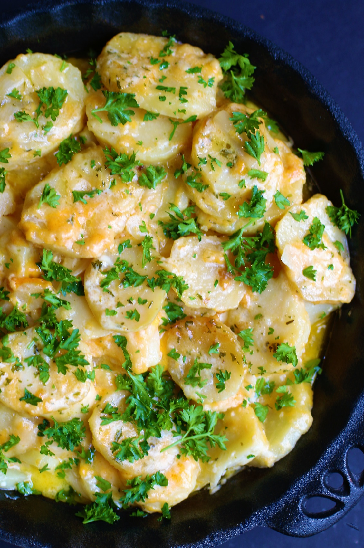

These Smoked Au Gratin Potatoes are the perfect side dish for any barbecue! Tender potatoes and onions are smoked before getting a slow braise in rich cream, three kinds of flavorful cheese, and the perfect blend of spices. They’re super cheesy, creamy and so easy to make! It’s hard to find a creamier and more delicious potato recipe than this – always a hit and there are never any leftovers!
INGREDIENTS:
8 russet potatoes peeled and thinly sliced
1 large yellow onion, peeled and thinly sliced
1-1/2 teaspoon salt
1 teaspoon garlic powder
1 teaspoon smoked paprika
1 teaspoon pepper
1-1/2 cups cheddar cheese (fresh shredded)
1-1/2 cups smoked gouda cheese (fresh shredded)
1 cup parmesan cheese (fresh shredded)
4 cups heavy whipping cream
8 Tablespoons (1 stick) butter (cut into pieces)
Fresh parsley, chopped

OPTIONAL MEAT:
1/2 lb. hickory smoked bacon (cooked until crisp & chopped)
2 cups smoked ham (chopped)

EQUIPMENT:
Smoker or Pellet Grill
Cast iron skillet or aluminum foil pan
Mandolin Slicer

HOW I MAKE THIS:
- If using a disposable aluminum foil pan, spray inside with non-stick cooking spray; if using a cast iron pan DO NOT spray with non-stick spray – your cast iron pan is already seasoned!
- In a small bowl, stir together the salt, garlic powder, smoked paprika and pepper until well combined; set aside.
- In a medium bowl, mix together the three shredded cheeses (cheddar, smoked gouda and parmesan); set aside.
- Peel and thinly slice the potatoes – you can use a mandolin so the slices all have a uniform thickness and nice round slices, or use a sharp knife and a steady hand to cut uniform slices. Potato slices should be NO MORE than ¼-inch.
- Peel and thinly slice the onions – you can also use a mandolin for this, or a sharp knife.
- PREHEAT SMOKER: Start your smoker and shoot for 250 degrees. I use a blend of hickory, maple and cherry woods for the smoke.
- PREPARE POTATOES: Layer 1/3 of the sliced potatoes and sliced onions in the bottom of the pan. (If you are adding optional meat, sprinkle ½ of chopped ham or bacon next.)
- Sprinkle with 1/3 of the spice mixture, 1/3 of the shredded cheese, and pour 1 cup of heavy whipping cream evenly over top.
- Add second layer by adding next 1/3 of sliced potatoes and sliced onions, sprinkle with 1/3 of the spice mixture and 1/3 of the shredded cheese. (If adding optional meat, sprinkle remaining ½ of chopped ham or bacon next). Pour 1 cup of heavy whipping cream evenly over top.
- Add third layer by adding last 1/3 of sliced potatoes and sliced onions, sprinkle with remaining spice mixture, shredded cheese. Top with sliced butter pieces, and pour remaining 2 cups of heavy whipping cream evenly over top.
- Cook the au gratin potatoes on the smoker uncovered for 1 hour at 250 degrees, then cover with foil and cook for an additional 3-4 hours or until the potatoes are fork tender.
- Remove from smoker, sprinkle with fresh parsley, serve warm and enjoy before they disappear!
- Refrigerate any leftovers in an airtight container for up to 3 days. To reheat, add a tablespoon or two of milk or half & half and stir before heating.
YIELD: Makes 12 servings
RECIPE VARIATIONS:
- Au Gratin Potatoes with Ham or Bacon: Add 2 chops of chopped hickory smoked ham or bacon that has been cooked crisp and chopped.
- Barbecue Brisket Au Gratin Potatoes: Add 2 cups of chopped brisket (with or without barbecue sauce) – we call these “Heavenly Smoked Au Gratin Potatoes” for a reason – SO GOOD!
- Herbs: Add fresh rosemary or thyme to the spice mixture.
- Spices: For an added kick, add a teaspoon of cayenne pepper or chipotle powder to the spice mix. For more barbecue flavor, add a teaspoon or two of barbecue seasoning to the spice mix.
- Cheese Variations: Almost any soft, fresh-shredded cheese will work in this recipe – I recommend sharp cheddar for the cheesiest flavor, but medium cheddar and white cheddar (or a combination of cheddar) works well. Smoked Gouda is wonderful, but you can also use regular gouda, or try shredded Swiss Cheese. Colby Jack or Pepper Jack also work well.
- Keto Variation: Replace potatoes with frozen broccoli or cauliflower for a cheesy and flavorful side dish!
RECIPE NOTES:
NON-STICK SPRAY: Even though it may be tempting, don’t spray a cast iron skillet with any type of non-stick spray, as they contain other ingredients that aren’t good for your pan – and your cast iron pan is already seasoned. If you are using a disposable aluminum foil pan, you can spray the inside before adding ingredients if you prefer.
EASY CLEANUP: You can use an aluminum foil pan for easy serving and cleaning, or use a large cast iron skillet if you prefer.
COOKING TIME: Cooking time will vary depending on how thick your potatoes are, how consistent the temperature on your smoker remains, and how tender and crisipy you prefer your cheesy potatoes. Begin checking them around the 3-hour mark and keep an eye on them until they reach your desired tenderness.
FASTER COOKING: To save two hours of cooking time, you can peel and slice the potatoes, then par boil with water and salt for 10 minutes; drain well and assemble as directions call for. Smoke at 250 degrees for 1 hour uncovered, 1 hour covered with foil.
MAKE AHEAD TIP: Prepare potatoes and cover pan with foil; refrigerate. Remove from refrigerator and let sit at room temperature for 1 hour before you plan to start cooking.
PREPARING THIS FOR A CROWD? If you plan on doubling this recipe, cook each batch in a separate disposable aluminum foil pan.
SERVE WITH:
- Grilled Steaks
- Prime Rib
- Brisket
- Smoked Turkey
- Smoked Ribs
- Smoked Ham
- Barbecue Chicken
- Glazed Salmon
- Smoked Pulled Pork
- Smoked Pork Chops
- Smoked Bacon Wrapped Pork Tenderloin
- Smoked Burgers
Original recipe created by Snowflakes & Coffeecakes; published May 2022.
© SnowflakesandCoffeecakes. All images, attachments & content are copyright protected. All rights reserved. Please do not use my images without prior permission. If you want to republish this recipe, please re-write the recipe in your own words, or link back to www.snowflakesandcoffeecakes.com for the recipe.

Tried it and loved it? Snap a picture and share it with me on Instagram @SnowflakesandCoffeecakes and by using the hashtag #SnowflakesandCoffeecakes.

